TECHNICAL PROJECT REPORT

# Title of Invention / Project:

# led wearable t-shirt

# Team Members / Inventors:

|  |  |  |  |  |  |
| --- | --- | --- | --- | --- | --- |
| **S.No.** | **Name** | **Department** | **Designation** | **Mobile** | **E-Mail** |
| 1. | Arshiya Mittal | CSE(IBM) | Student | 7973875844 | arshiya.mittal2000@gmail.com |
| 2. | Sudiksha | CSE(IBM) | Student | 7988742304 | sudiksha621@gmail.com |
| 3. | Ishita Raghuwanshi | CSE(IBM) | Student | 6280905174 | ishitaraghuwanshi2001@gmail.com |
| 4. | Khushal Thakur | ECE | Mentor | 9646030764 | khushal.thakur@cumail.in |
| 5. | Anshul Sharma | ECE | Mentor | 9478697475 | anshulsharma.ece@cumail.in |
| 6. | Kiran Jot Singh | ECE | Mentor | 9463909689 | kiranjotsingh.ece@cumal.in |
| 7. | Divneet Singh Kapoor | ECE | Mentor | 9878422653 | divneet.ece@cumail.in |

Section – 1 (IPR Related)

* Our project is a patterned requires an external battery LED t-shirt. It helps one to look fashionable and different. It makes one stand out from the crowd. A person can express their unique and different style through a LED t-shirt. A person can also showcase their personality and fashion statements in public like at parties or gatherings etc. It requires an external battery for the t-shirt to light up. It looks trendy and can be a source of attraction.

The battery can be excluded and an internal source of power supply can be provided for the LEDs to glow up with the help of new technology as Incandescent which create light as a by product.

LEDs draw very little power and can be run for a long time on a small battery hence, no need for a bulky wall transformer and a wall plug to light it up.

* Instead of LED, LCD display can be used which is much more attractive and expressive and will be a better technology work.

# Existing state-of-the-art and Drawbacks in existing state-of-the-art:

|  |  |  |
| --- | --- | --- |
| **S. No.** | **Existing state of art**  **Patent No.** CN202819678U | **Drawbacks in existing state of art** |
| 1 | This unit consists of LED matrix, LED driver circuit. This unit communicates with the unique mobile phone application and glow LEDs in terms to the strings or patterns received. The mobile phone application would allow the user to control the t-shirt LED matrix. This connects with the control unit mentioned above. Once the user has selected the type of information, it allows the user to save the pattern which can be accessed later on. | Needs more improvement with the various new technologies, design and wearibility. |

# drawbacks:

The LEDs can be attached in different designs and patterns. Instead of LEDs LCD display can be used. In today’s world technology has advanced that what we type on our mobile phones can be displayed on a t-shirt with help of LEDs.

# Advantages:

The next big fashion statement. Fashion statements just got a whole lot more literal with the advent of LED clothing. Various companies are taking the idea of the LED-enhanced dresses and clothing lines into more attainable markets, allowing the average consumer to get their hands on their own technologically advanced t-shirts, jackets and even shoes.

# Block diagram :

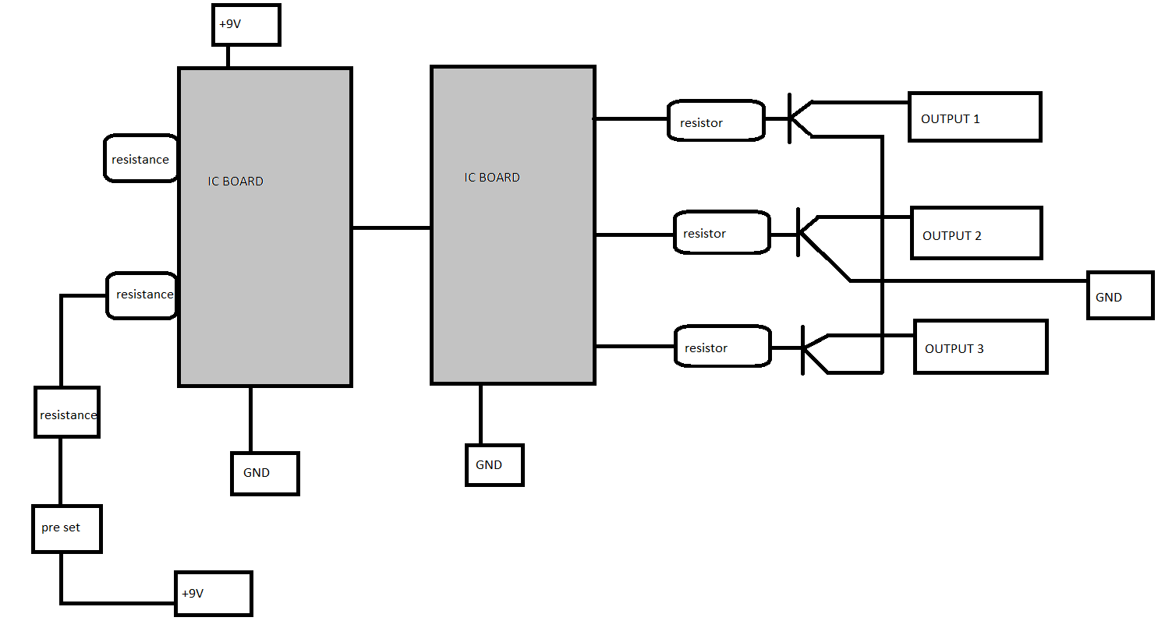

Section – 2 (Real Project)

# Materials Required:

|  |  |
| --- | --- |
| Serial No. | Materials |
| 1. | Wires |
| 2. | Soldering Material |
| 3. | I.C board (2) |
| 4. | LEDs (40)   * 16 LEDs * 8 LEDs each on both shoulders. * 24 LEDs * 12 LEDs each on front and back on bottom . |

CIRCUIT DIAGRAM:

**-**

12V

+9v

4 8

7

8

3

2

6

1

16

3

14 2

15

7 4

8

1k

10k

100k

+9v

# Steps of Circuit Completion:

* The timer 555 is taken which is of 8 pins and then it's pin 2 and 6 of the resistance is connected to the 10kresistor and the preset of 100k which is further connected to the +. The pin 1 is connected to the ground.Then the wire is stretched in between timer 555 and the integrated circuit board cd4017 (16 pins ICboard) to pin 14 of IC where, pin 16 is connected to the +9v and resistor connected to pin 15 and 7. Thepin 8 is connected to the ground. Now, The pin 3,2, 4 are connected with the 1k resistor,these three pinsare in parallel from their the pin 3 gives the output 1 and the other wire goes and connect to the one of thewire of the pin 4 and pin 2 gives output 2 where at pin 2 one is connected to ground,at pin 4 one givesoutput 3 and other connected to the one of the to pin 3.
* Now at the bottom of the t-shirt the 12 LEDs are taken. LEDs are divided in pair of three the 1stLED positiveconnect to the negative of the I.st led in second order same with 2nd and 3rd led. In the second order itcontinues the same the positive of 1st, 2nd, 3rd LEDs are connected to the negative of third order series LEDs. Now, the last order LEDs are left with their positive pins which all will connect and brought together to thepositive of 9v battery.
* Now, at the shoulders the 8 LEDs on each shoulder is attached where we have made a series of 4 LEDswhere each of the positive connected to the negative of each LED. The LEDs are connected in series. The negative of 1st and the 8thLED is left where the wire from these both will come and then connected with the negative of the 1st LED negative leg of first order LED attached at the bottom.
* Now, that negative wire will go and connect to the battery. Same circuit is followed by the second shoulder LEDs